Explain the below linux commands with an example. Share the screenshot of each command with the output:

1 )PWD

This commands print the current working directory.

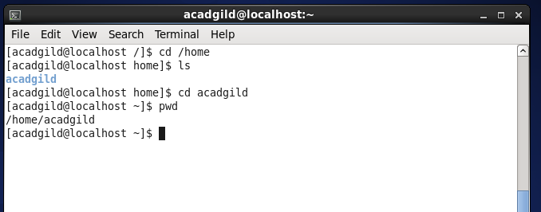

2. vi :

you can open a file with vi for editing using the following:

Here we are opening the file name testFile.txt

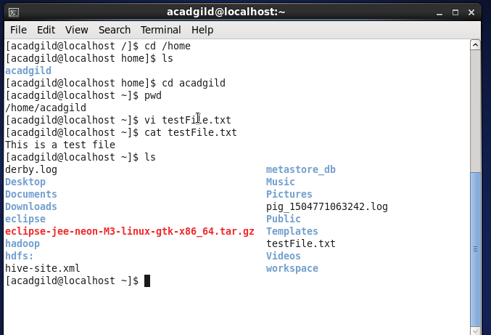

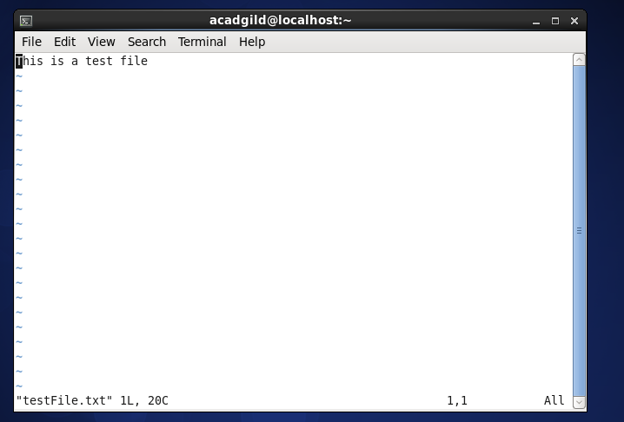

he vi editor has 3 modes in which it performs its functions.The default is COMMAND mode, in which tasks like copy, paste, undo etc can be performed. You can change a mode from command mode only (and come back to it).The second mode is the INSERT mode, in which whatever key you type is treated as a character and will be loaded into the file buffer. To enter this mode, press ‘i’ when in command mode.  
Final mode is EX mode or last line mode. The changes made in the buffer can be saved or discarded in this mode.

3. touch :

For creating an empty file, use the touch command.Here we are creating the file name craeate_file_

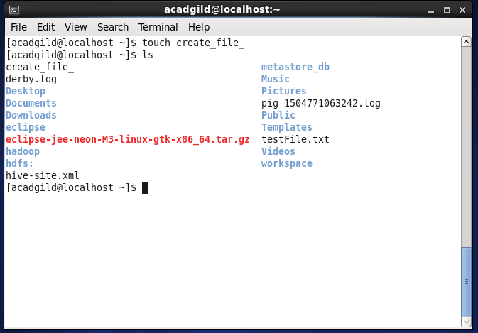

4. mkdir

To create a directory, the ‘mkdir’ command is used.Here we are making the directory named as linux_command.

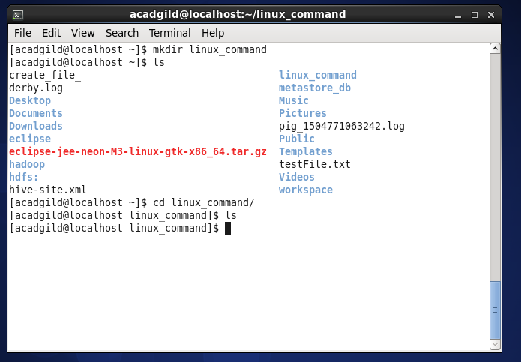

5. rm

This command removes the file.

Example: As we have created the file name as testFile.txt ,we will remove it by rm command .

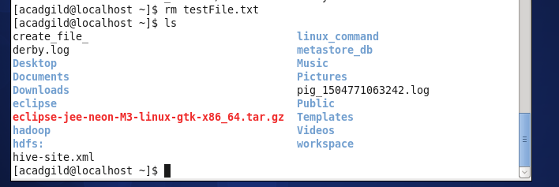

6. ls

Listing File And Directories Command

List files and/or directories. If no argument is given, the contents of current directory are shown

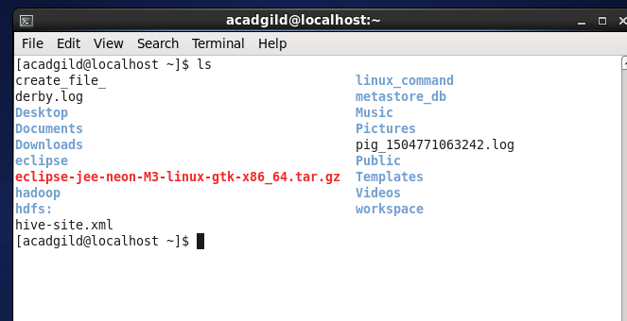

7. echo

This command will echo whatever you provide it.

he ‘echo’ command is used to display the values of  a variable. One such variable is ‘HOME’. To check the value of a variable precede the variable with a $ sign.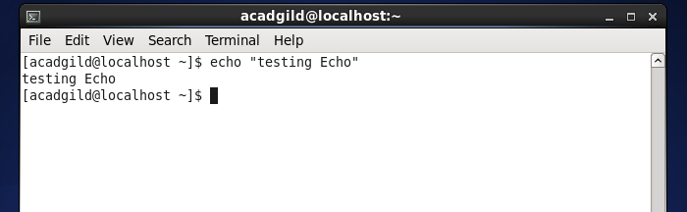

8. cat :

The 'cat' command is actually a concatenator, but can be used to view the contents of a file.

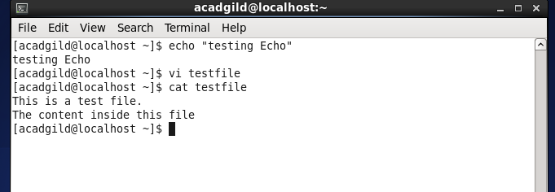

9. who

This command reveals the user who is currently logged in.

The standard **Unix command** who displays a list of users who are currently logged into the computer. The who **command** is related to the **command** w, which provides the same information but also displays additional data and statistics

10.cd

#### Changing Directories Command

$ cd [path-to-directory]

Change the current working directory to the directory provided as argument. If no argument is given to ‘cd’, it changes the directory to the user's home directory. The directory path can be an absolute path or relative to current directory. The absolute path always starts with /. The current directory can be checked with ‘pwd’ command (remember?):

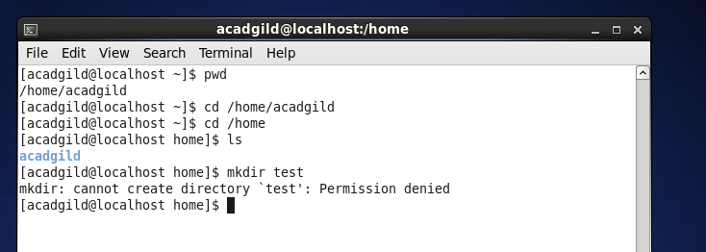

11.date

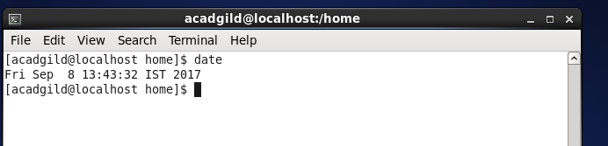

12.cal

Displays the calendar of the current month.

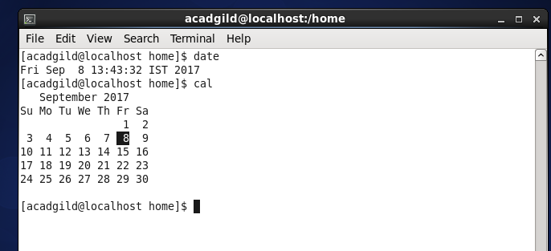

13.mv:

The **mv** command is used to move or [rename](https://www.computerhope.com/jargon/r/rename.htm)files.

Move1 folder contains file1 and we will move it to folder Move2 and the file1 will be removed from Move1 folder and will be copied to Move2.

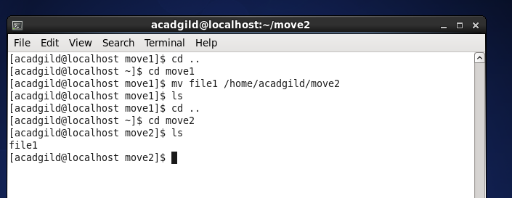

14.cp :

Copy files and directories. If the source is a file, and the destination (file) name does not exit, then source is copied with new name i.e. with the name provided as the destination.

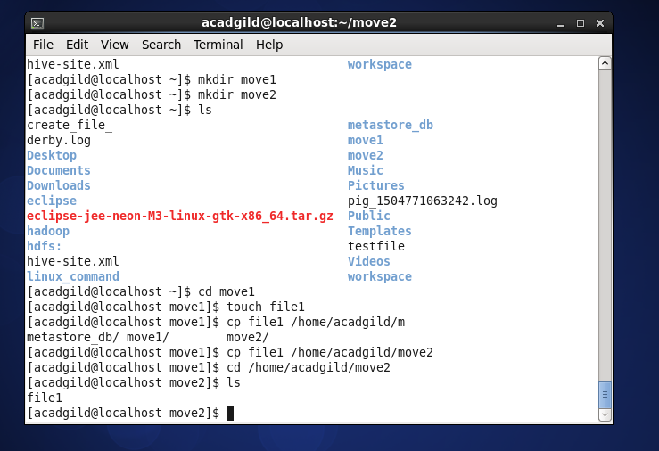

15.which:

Locates the pathname of the file which would be run if the [**sh**](https://www.computerhope.com/unix/ush.htm) command were executed. On most systems, this will output:

